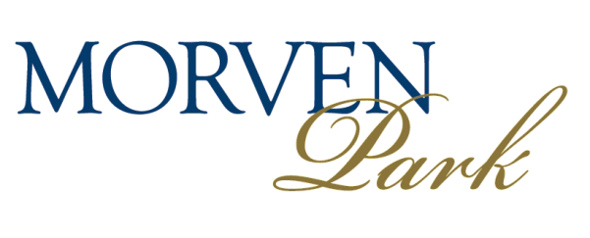
Volunteer at Morven Park! Whether you are interested in history, art, artifacts, nature, agriculture, sports, horses, marketing, fundraising, museum administration and more, we have volunteer opportunities to meet all interests and skills. Simply fill out the form below and hand it in at our Visitor Center or email it to info@morvenpark.org and one of our staff members will be in touch.

Please check all areas of interest:

Architectural Preservation Archaeology

Museum Collections Care Educational Programming

Nature/Agriculture Field Sports

Equestrian Fundraising/Marketing

Events Other

Thank you!

Name:_______________________________________________________________________

Address: _____________________________________________________________________

Email: __________________________________________ Phone: _______________________

Any relevant experience/skills/abilities:_____________________________________________

_____________________________________________________________________________

Availability: ___________________________________________________________________

Potential start date: ____________________ Potential end date: ________________________

